# Configuring Talaria TWO Project

1. After installation, to run the project from Visual Studio, use the Open Folder option.
2. Select anyone of the example or apps folder available in SDK.
3. VS code:
   1. Download and unzip the provided Talaria TWO SDK.
   2. Open VS Code Editor.
   3. Click on File -> Open Folder.

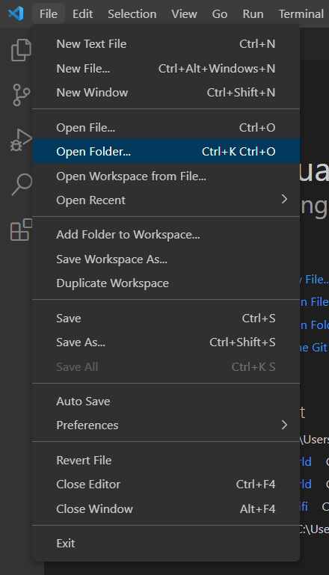

Figure 14: Import an existing example in VS Code

1. Select any example app folder available in SDK and click on OK.

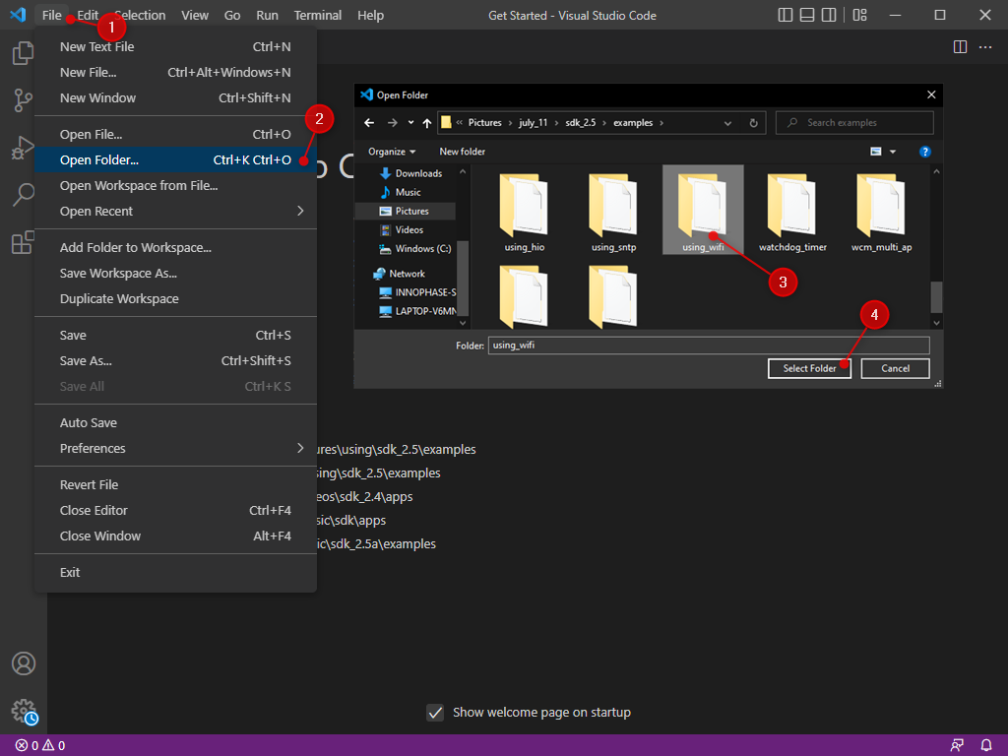

Figure 15: Creating a project in VS Code

1. Select File option available in tools bar.
2. Select -> open Folder
3. Select any of the example folder
4. Click on Select Folder option